Paleolithic Era
Hominids Neolithic Era
- Homo Habilis

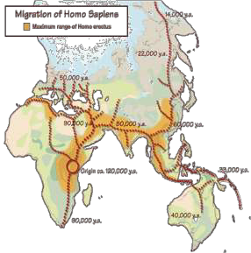
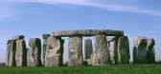
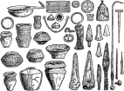
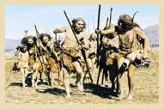
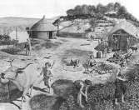
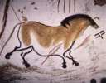
- “O___ S______ Age”
- N_________
o Followed migrating a_______ in search of food
- Small C_______
- H______-Gatherers
- Make F____
- Simple T_____

Science

- A_____________
- Anthropologists
- Paleontologists
- A__________
- F________
- C_______ Dating
- Louis & Mary Leakey

Caves at Lascaux.
France
  - Homo Erectus
  - Homo S_______
    - Neanderthal
    - Cro-Magnon

Paleolithic Era to Agricultural Revolution

“P_______” – time before writing

Places
- Olduvai Gorge – East A________ (Tanzania)
o O________ hominid discoveries
- N___________ Settlements
- A_______ (Syria)
- Ç________ (Turkey/A______Peninsula)
- Jericho (Eastern M________________)
- S__________
o England
- “New Stone A_____”
- A_____________ Revolution
- Stable, permanent Communities
- D_________________
- Plants
- Animals
- A___________ Tools

Migration from Africa

