Civilizations Terms Judaism
- Ziggurat

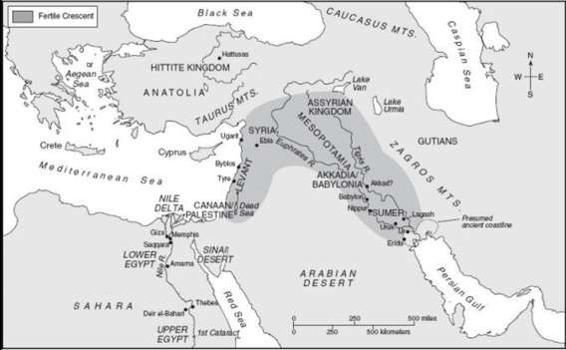
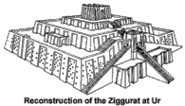
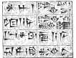
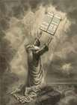

Hebrews
  - 1st M_________ Religion – J______

Sumer
  - World’s 1st City-States
  - 1st Written Language – C________

Phoenicia
  - 1st Mediterranean Traders
  - 1st A_________

Akkadians
  - 1st Empire – Sargon

Babylonians
  - 1st Law C_____ – H____________

Hittites
  - Anatolia Peninsula – 1st Ironworkers

Assyrians
  - Military Supremacy

Chaldeans
  - Advances in Astronomy
  - Hanging Gardens of Babylon – Nebuchadnezzar

Lydians
  - 1st Coins – Replaces Barter
    - Stylus
    - Flax
    - C____-_____

Ancient River Valley Civilizations - Mesopotamia

Geography

H_______
- 1st Monotheistic R_________
- A________ – “Father” of Judaism
- M______– Led Hebrews on E_______ Solomon – King unites 12 Tribes
- T______ – Holy B_____
- T___ C______________– Moral L___
Code
- E_____– Jews enslaved in Babylon
- D______ – Dispersal of Jews around the World – Cultural D__________

