Governments & Religions

Monarchy
- Empires
- D___________
- Polytheism
- M___________
o J_________
Characteristics of Civilization

- Division of L_______
- Complex S______ Institutions
  - Ex. Government, Religion
- Advanced T__________
- Calendar
- Written L__________
(Last Aspect to develop)
Economic Patterns

- Use of new m_______
  - B_______ & I_______
- Increased A__________ Production
  - Use of I_________ Systems & Plows
- T_____ begins
- World’s 1st C______ Develop - Sumer
- Use of S_______ for Labor

Ancient River Valley Civilizations

“The Firsts of Everything”

Literature
Written Language

- Pictograms
- C_________
  - Sumer
- H__________
  - Egypt
- Alphabet
  - P_______

Locations
- The Epic of Gilgamesh
st

- Mesopotamia

World’s 1
Epic
Law Codes

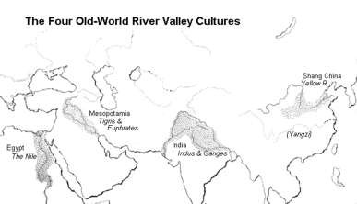
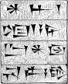
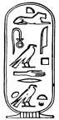
o T___ & E_______
- Egypt
  - N_____
- Indus River Valley
  - I______
- C_____
  - Huang He
- H____________’s Law Code
  - Unified B__________ Society

Harsh L_____
  - Strict c______ distinctions

